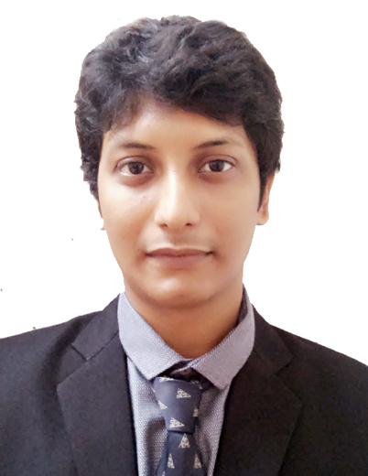 **ABHISHEK BHATTACHARYA**

41/B RAJA RAMMOHAN SARANI

PS – AMHERST STREET

Pin-700009, West Bengal

Mob: 9831495662/ 7980800789

Email – [aoabhismart3@gmail.com](mailto:aoabhismart3@gmail.com)

**Objectives**

To work in an organization where I will get an excellent work environment and can get an opportunity to enhance my skills and knowledge for the growth of my organization and myself.

**SKILLS-**

* Skilled in delegating task and motivating Team players to achieve best goals.
* Strategic plans for build and lead creative teams that develop pioneering products.
* Excellent in presenting and communicating complex ideas clarity.
* Friendly and open-minded; committed to client satisfaction.

**Education Qualification**

* MBA in Marketing from Punjab Technical University in the year 2012. From Annex college Salt lake.
* Graduated Bachelor of Science (BIOS) from Calcutta University in the year 2008. From Vidyasagar college Kolkata.
* Passed Higher Secondary examination (Science) from West Bengal Council of Higher Secondary Education in the year 2005. From A.V school.
* Passed Secondary School examination from the West Bengal Board of Secondary Education in the year 2003. From Scottish Church Collegiate school.

**Working Experience**

* Worked in BEAUTY GLASS PRIVATE LIMITED as **Sales Officer** for Kolkata, Siliguri, and Entire North Bengal from APRIL 2015 to November 2015
* **Job Profile: SALES OFFICER**

**RESPONSIBILITIES**

* **a) Market Expansion** by strong dealers’ network.
* **b) Distributor** handling with proper business follows up every month.

**C)** Collection of receivables from the market.

Above all my most important task is to build a strong Dealer base to increase visibility of the brands assigned to me in my territory and gaining confidence of my dealers to sell my brand in tandem with the market trends and gradually taking bigger shelf space in my entire dealers counter.

* ***Worked in ASTRA LIFESTYLE*** as Area Sales Executive for West Bengal, Bihar, Jharkhand, Orissa, from April 2014 to April 2015.

**Job Profile**: SALES EXECUTIVE EAST INDIA

**RESPONSIBILITIES**

1. Market Expansion by building strong dealers network and building opportunities in the existing and new market for my brands.
2. Market penetration by reaching out to the dealers in the interiors and farthest most places in my territory.
3. Visual Merchandising and Branding through local vendor.
4. Collection of receivables from the market.
5. Showing sample for new collections to the Market and collecting fresh and repeat order.

* **Worked** in Evac Engineering pvt Ltd (VOLTAS AC AUTHORISED CO) as a supervisor from August 2012 to December 2013.

**RESPONSIBILITIES** are to supervise the Project work Provide by VOLTAS.

**Presently working under JK CONSTRUCTION** as a Supervisor and Project Instructor.

**Computer Proficiency**

* Basic computer knowledge (MS Office, Words, Excel)
* Basic knowledge of Internet.

**Extra Curricular Expertise**

* Trained western dancer and participated in many Cultural Program. and activities
* Has participated several sports event in school and won prizes.
* Passionate to accept new challenges in Life.

**Personal Information**

* Father’s Name Mr. Pulak Bhattacharya.
* Date of Birth 14th of July 1987
* Sex Male
* Language Known English, Hindi and Bengali.

Place: Kolkata

Date: (ABHISHEK BHATTACHARYA)